Instructor ;BAGHDADI.M

***Ahmed Zabana University of Relizane***

***Faculty of economics, business and management science***

***level : Master 1 Financial Institution***

***Syllabus***

Lesson 01 : The Company

Lesson 02 : The Features of Multinational Enterprises

Lesson 03: The Job Roles in Business Organizations

Lesson 04 : The Accounting

Lesson 05 : Centralization versus Decentralization in transnational corporation

**lesson 01** : The company

Definition ;

Company means a business its self , company is a legal entity that people form ,it allows them ,usually as shareholders ,to buy and sell goods or services ,the most companies want to make a profit however some companies are non- profit organizations

Company means a business

Office means employee’s specific work area .

Company’s structure

Headquarters : The main ( the most important office a company has

Department : All of the employees of a specific type in a company .

Industry : All of the companies of a specific type .

Branch: a division that operates in a certain area .

|  |
| --- |
| An example of a company organization chart  Source: Mackenzie, 1997, page 20 |

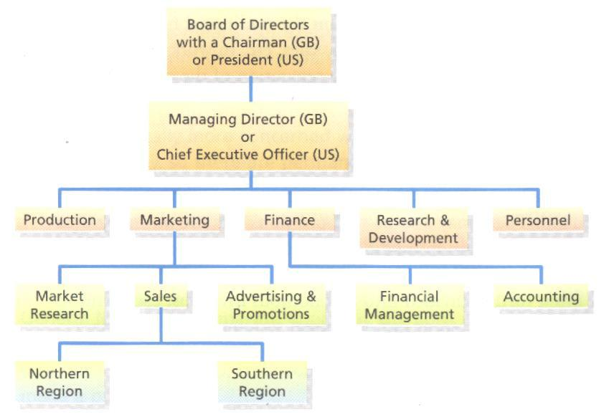

Reminder :

Company : when we talking about an entire Business

Office : For the physical area where the employees work

Headquarters : for a company’s main important office

Department ; For a the employees of a specific types in a company

Industry : For the companies of a specific type

Branch : For a specific section /area of a company

**lesson 02:** Features of Multinational Enterprises .

Multinational enterprises (MNE):a business entity which conducts business operations in a various countries with its subsidiaries and affiliates .It posses considerable and wide human resources finance ,expertise and technology as we as enjoy substantial competitive advantage .

**Types of multinational enterprises :**

Multinational decentralized corporations :every branch office has decentralized management structure with no central chain of command for decision-making .

Global centralized corporation :centralized firm manages and controls the international units from the headquarters in a home country .

International company : in this , the global branches adhere to the parent company’s technology improvisations occurs in the headquarters .

Transnational enterprises : it is the blend of all the above three forms of MNC ,the parent company guides but not controls the functioning of its global branches .

**The features of MNEs:**

*large scale operations the basic feature of MNEs is that their area of operations is vast

*large number of branches they operate a global level and have branches in different countries .

*Huge turnover : the amount of MNE is high which they able to pay a good amount of salary to their employees

*High products quality : the product that produced by MNEs are of high quality

*Large scale advertising : another essential feature that they invest huge amount of money in their advertisement and publicity activities .

*Control from the home country

*Advanced technology : they focus on best level technology .

**The advantages of MNEs :**

**1/ Fore the country :**

*Financial gains

*Increase in business

*Job creation

*access to more goods and services

*assistance in economic development

**2/Fore the company :**

*Access to new markets

*Cost efficiency

*More creativity and innovation

*Global brand recognition

*Diversified work

|  |
| --- |
| Task : write a short essay where you talk about the disadvantages of multinational enterprises . your work should be in less two pages |

**Lesson 03 :** Job Roles in business Organizations

**Organizational Jobs** : job is a role that exists in the organization and comprises a common set of responsibilities .This includes all the task types whether is system or manual .For example a manager’s job incudes performing the function of department of manager ,and being a responsible for a direct report employees .

**Types of business roles :**

In many organizations , Business roles follow an organization structure ,where employees designate executive –level ,managerial and operational roles .

1/ Executive : executive - level includes senior level position and often features a central executive in charge of entire organization or large department

2/ manager :

Manager and supervisors make up many of essential mid- level business roles within an organization

3/ Operation and production :

At this level , business roles can encompass one or more professional fulfiing the responsibilities of a same role specially in large one ,but in small organization , we find one professional .

4/ Chief Executive Officer ( CEO) :

CEO of a company is the leading role responsible for making top-level decisions.

5/Chief Operating Officer ( COO) :

COO oversees the company s operations , in small organization COO oversee various department to ensure employees are completing their work property end in timely manner .

6/ Chief Financial Officer ( CFO) : CFO or the controller is a responsible for cash flow and the financial success of business .

7/ Chief Marketing Officer ( CMO) :

Direct marketing plans marketing department of their company .with their own teams or marketing manager , he makes the final decisions of marketing projects.

8/Chief Technology Officer (CTO) :

Manages the technological function of their organization integrate technology trends .

9/ President : some organization designate a president instead of a CEO, a president many take on additional tasks , that a CEO may not .

9/ Vice president :The vice president initiates decisions and plans by directing mid-level manager and team leaders .

10/ Executive Assistant : Usually reports directly to the CEO and handles much of the CEOs administrative tasks .

11/ Accountant : An accountant oversees the day -to day transactions of companies ,including sales transactions ,expense payment and tax reporting .

12/Sales Representatives : Connect with customers to sell their business product or services .

13/ Customer Service Representative : Help customer solve their problems .Handle product returns and refund and solve issues when customers are unsatisfied .

14/ Administrative Assistant : The administrative assistant ,office assistant or receptionist serves as the first point contact for visitors and clients entering of business, they may perform many essential tasks such as managing the phone lines ,communicating between cilent and business partners ,and keeping schedules organized .

**Lesson 04**: Accounting .

**1/ Accounting definition :**

Accounting is the process of recording financial transactions pertaining to a business. The accounting process includes summarizing, analyzing, and reporting these transactions to oversight agencies, regulators, and tax collection entities. The financial statements used in accounting are a concise summary of financial transactions over an accounting period, summarizing a company's operations, financial position, and [cash flows](https://www.investopedia.com/terms/c/cashflow.asp).

**Types of Accounting**

[**Financial accounting**](https://www.investopedia.com/terms/f/financialaccounting.asp) **:**

refers to the processes used to generate interim and annual financial statements. The results of all financial transactions that occur during an accounting period are summarized into the balance sheet, income statement, and cash flow statement. The financial statements of most companies are audited annually by an external CPA firm. For some, such as publicly traded companies, audits are a legal requirement.6 However, lenders also typically require the results of an external audit annually as part of their debt covenants. Therefore, most companies will have annual audits for one reason or another.

[**Managerial accounting**](https://www.investopedia.com/terms/m/managerialaccounting.asp)

uses much of the same data as financial accounting, [but it organizes and utilizes information in different ways](https://www.investopedia.com/ask/answers/041015/how-does-financial-accounting-differ-managerial-accounting.asp). Namely, in managerial accounting, an accountant generates monthly or quarterly reports that a business's management team can use to make decisions about how the business operates. Managerial accounting also encompasses many other facets of accounting, including budgeting, forecasting, and various financial analysis tools. Essentially, any information that may be useful to management falls underneath this umbrella.

**Cost Accounting**

Just as managerial accounting helps businesses make decisions about management, cost accounting helps businesses make decisions about costing. Essentially, cost accounting considers all of the costs related to producing a product. Analysts, managers, business owners, and accountants use this information to determine what their [products should cost](https://www.investopedia.com/ask/answers/060915/what-difference-between-transfer-price-and-standard-cost.asp). In cost accounting, money is cast as an economic factor in production, whereas in financial accounting, money is considered to be a measure of a company's economic performance.

## Forensic accounting

Forensic accounting combines accounting, auditing, and investigative skills to examine the finances of an individual or business. Forensic accountants compile financial evidence and can communicate their findings using reports and presentations in legal proceedings. This type of accounting is often used in fraud and embezzlement cases, as it provides a detailed explanation of the nature and extent of a financial crime.

## Fiduciary accounting

Fiduciary accounting is the recording of transactions associated with a trust or estate. It is dealt with on a cash basis. Cash is recorded when it is received and disbursements are recorded when paid. This information is then provided to beneficiaries and often the courts.

## Auditing accounting

Auditing accounting is an objective examination and evaluation of a company's financial statements done internally or by a government entity, such as the Internal Revenue Service .

**Lesson 05** : Centralization versus Decentralization in transnational corporation

**Centralization VS Decentralization :**

Who makes decision ? Decision –making is about authority .Akey question is whether authority should rest with senior management at center of business ( centralized) , or whether it should be delegated further down the hierarchy ,away from the center (decentralized ) .

**1/ Centralized decision –making :**

Business with a centralized structure keep decision –making firmly at the top of the hierarchy ( amongst the most senior management ).

**A/ Possible Benefits of Centralization :**

* Easier to implement common policies and practices for the whole business
* Prevents other parts of business from becoming to independent .
* Easier to co-ordinate and control from the center .
* Economies of scale and overhead savings easier to achieve .
* Quicker decisions –making (usually) easier to show strong leadership .

**B/ Possible Drawbacks of Centralization :**

*More bureaucratic –often extra layer in the hierarchy .

* Local managers are likely to be much closer to customer needs

*Lack of authority down the hierarchy may reduce manager motivation

* Customer service : lost flexibility and speed of local decisions –making .

**2/ Decentralized Decision –making :**

In a decentralized structure ,decision – making is spread out to include more junior manages in the hierarchy ,as well as individual ,business units or trading locations

**A/ Possible Benefits of Decentralization :**

*Decisions are (making ) made closer to the customers .

*better able to respond to local circumstances

*Improved level of customer service

*Can enable a flatter hierarchy

*Good way of training and developing junior management

*Facilities empowerment : should improve staff motivation

B/ Possible Drawbacks of Decentralization:

*Decision –making not necessarily “strategic”

*Harder to ensure consistent practices and policies at each location

*May be some diseconomies of scale

*Who provides strong leadership when needed e.g . in crisis ?

*Harder to achieve tight financial control –risk of cost –overruns

***Good luck***