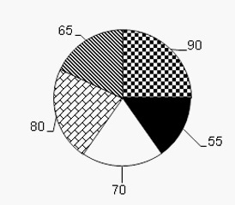Fractions and percentages

1. **Percentages :**

**%** is called percent

We use it before the noun phrase and we add the proposition “of”.

*Figure 1: pie chart*

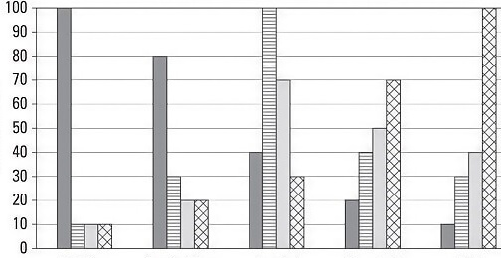Eg: 25% of people prefer ice-cream.

*Figure 2 : bar graph*

|  |  |
| --- | --- |
| **55%** | **fifty-five per cent** |
| **100%** | **one hundred per cent** |
| **365%** | **three hundred and sixty-five per cent** |
| **4.25%** | **four point two five per cent** |
| **4.025%** | **four point oh two five per cent** |

1. **Fractions :**

***1) Rule:***

|  |  |
| --- | --- |
| **1/3 1/8**  **1/10** | **One third an eighth**  **One tenth** |

But now from 1/11 onwards: ALWAYS 'one':  1/12 = one twelfth

***2) More examples:***

|  |  |
| --- | --- |
| **2/3 3/10**  **5/7** | **two thirds three tenths**  **five sevenths** |

***3) Exceptions:***

|  |  |
| --- | --- |
| **1/2 1/4** | **a half / one half a quarter / one quarter** |