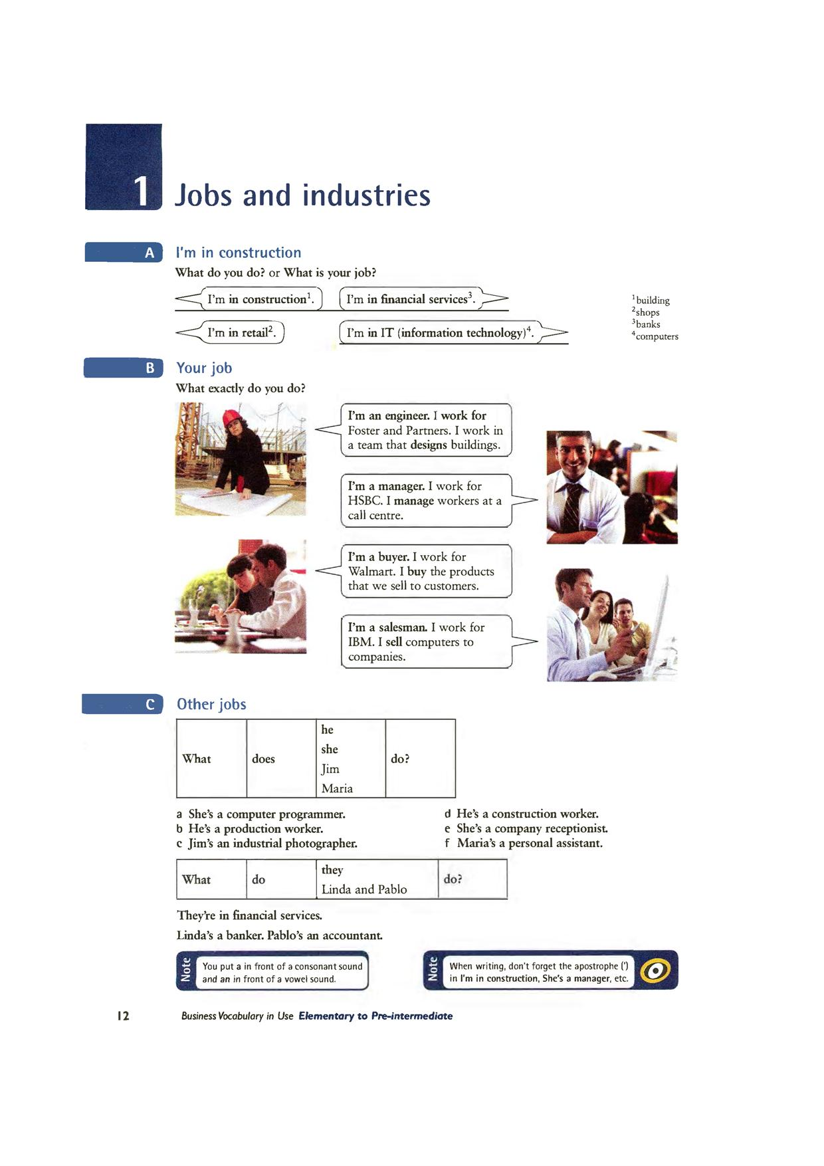

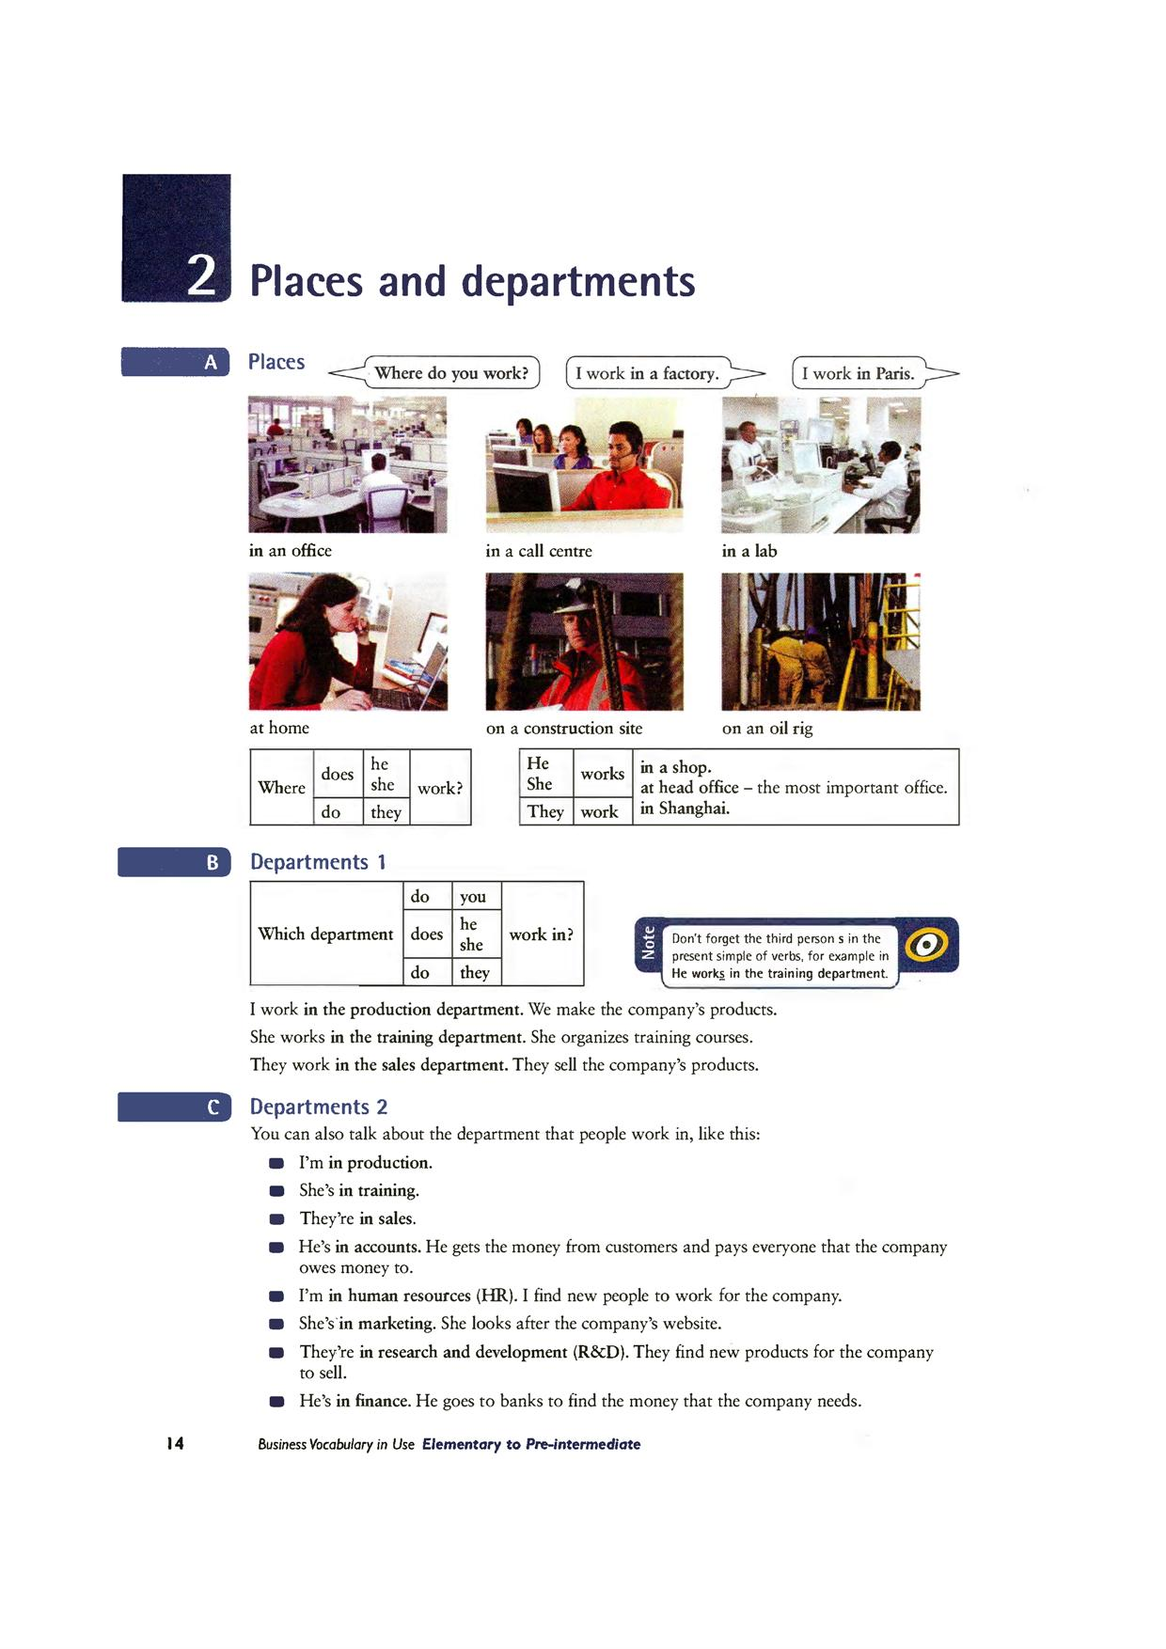

***Practice***

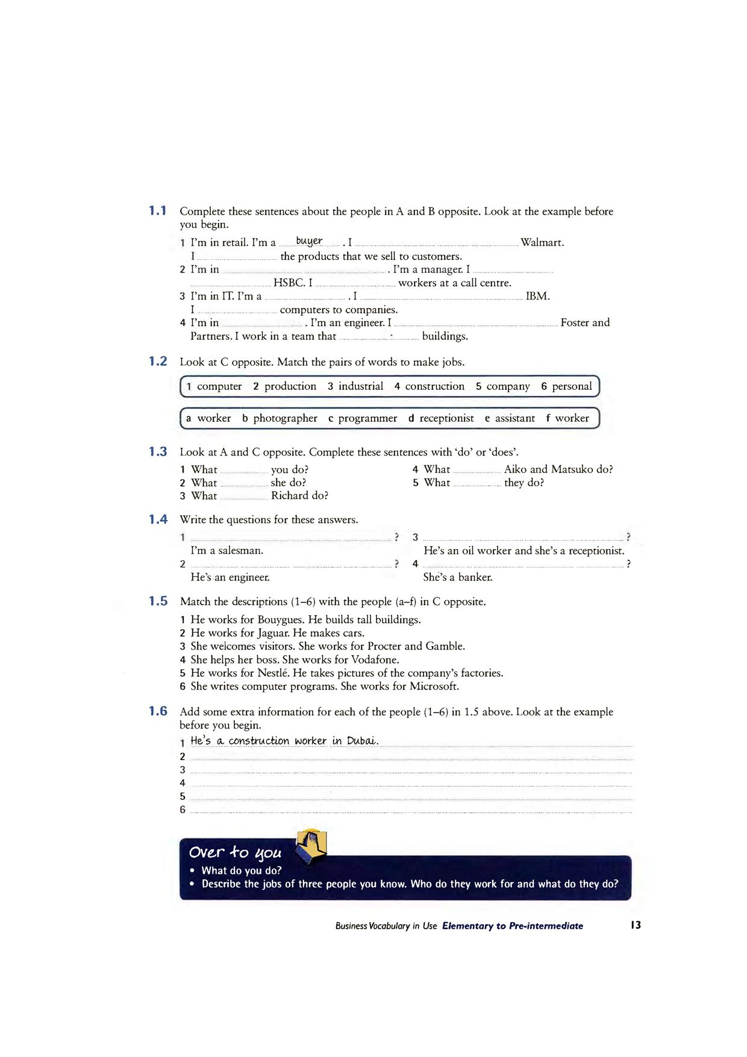

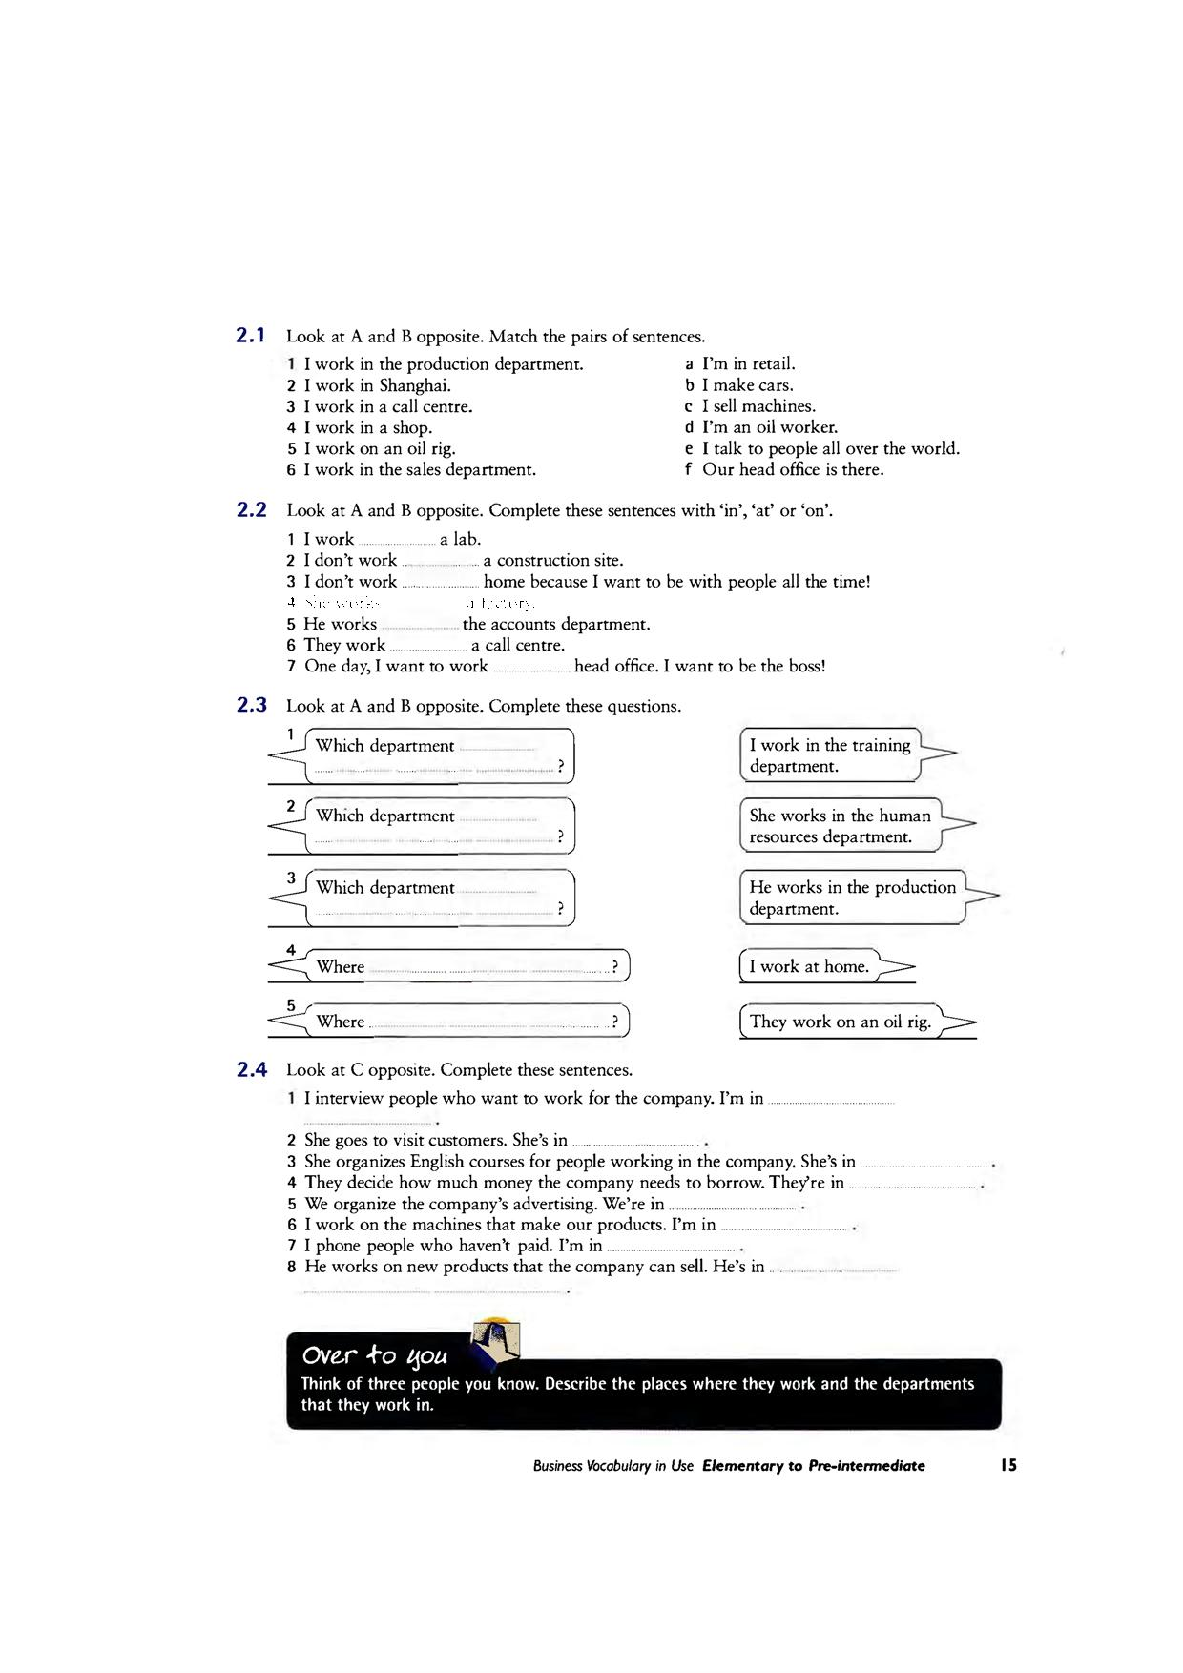

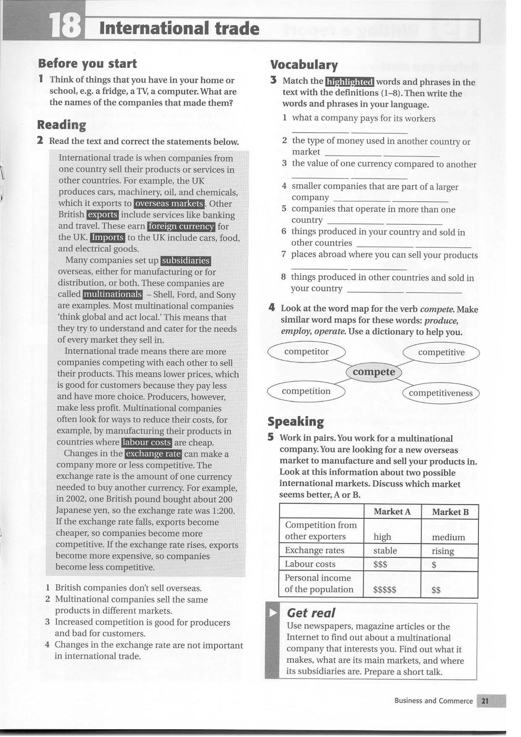

Free enterprise economy, also called The capitalist economic system is a politico-economic mode of production in which all decision on the management of the community are made by individuals this type of economy is based on the following criteria.

* Private property, i.e. private ownership and control of the means of production.
* Private profit, i.e. creation of economic activities by individuals in order to make more profit.
* Creation of market structure which regulates these economic activities.
* Laissez-faire principles which lead to competition between the different supplies of goods and services.

In this mode of production, the state does not intervene in other economic sphere. Its role is supportive rather than interventionist. In other words, the state seeks to provide the conditions which are necessary for the economic framework to prosper.

In the later forms of capitalism, the role of the state has become more influential and significant, in the sense that it attempts to control the economy. The aim of such interventions is to create stability and to protect local capital.

**A/**

***1. Say whether the following statements are true or false.***

**1-** The capitalist economic system is based on liberal principle.

**2-** The owners of capital always seek to provide the necessary condition for them to make more profit.

**3-** In the capitalist economic system, the workers control the means of production.

**4-** The role of the state in " pure" capitalism into intervene in the economic sphere.

**2. Provide a title to the text.** ……………………………

**3. Synonyms:**

Firm =………………. Considerable=………… Intercede= ………………. Ways =……………….

**B/**

**1.**Write the correct question to ask about the underlined word.

Q: ………………....? A:  Donald Trump said that.

Q: ……………...… ? A:  I study English.

Q: ………….…….. ? A:  May 08th  is mother`s day.

Q: ………..………. ? A:  They went to a party.

Q: ………………… ? A:  My brother is coming.

Q: ………………… ? A: She called her mother.

|  |  |
| --- | --- |
| **2**.Select the right wh-question and make the necessary changes: |  |
|  |  |

* (…….. / John / come from)?

………………………………………….

* (……………... / it / take from London to Paris)?

…………………………………………

* (………. time / the film / start)?

…………………………………………

* (……… / you / play tennis)?

…………………………………………

* (………….. sports / Lucy / like)?

…………………………………………

* (……………… / they / get to work)?

………………………………………

* (…………….. / she / lived)?

………………………………………

* (……….. / you / ate so much chocolate)?

………………………………………

* (………/ this machine / do)?

……………………………………...

