A CV stands for the Latin phrase “curriculum vitae” meaning “course of life” is a [short](https://dictionary.cambridge.org/dictionary/english/short) detailed  [description](https://dictionary.cambridge.org/dictionary/english/description) of [your](https://dictionary.cambridge.org/dictionary/english/your) [education](https://dictionary.cambridge.org/dictionary/english/education), [qualifications](https://dictionary.cambridge.org/dictionary/english/qualification), [previous](https://dictionary.cambridge.org/dictionary/english/previous) [jobs](https://dictionary.cambridge.org/dictionary/english/job), and sometimes also [your](https://dictionary.cambridge.org/dictionary/english/your) [personal](https://dictionary.cambridge.org/dictionary/english/personal) [interests](https://dictionary.cambridge.org/dictionary/english/interest), that you [send](https://dictionary.cambridge.org/dictionary/english/send) to an [employer](https://dictionary.cambridge.org/dictionary/english/employer) when you are [trying](https://dictionary.cambridge.org/dictionary/english/trying) to get a certain [job](https://dictionary.cambridge.org/dictionary/english/job).

**Tips for writing a professional CV:**

* Check the format: Consult the job announcement to see what format an employer wants your CV to be in. If it isn't indicated there, use a standard one, like .docx or a PDF.( Use 2.5 cm for margins /stick with one font and one size).
* Keep it professional: Make sure you use an email address that sounds professional. A silly or suggestive one could get your CV tossed.
* Adjust your grammar: since you have lots to say, but little space, leave out sentence subjects **(e.g. I, my manager)**, possessive pronouns **(my/mine, his/hers)**, and sometimes even articles **(the, a)**. If you're listing more than one accomplishment in a sentence you can replace **"and"** with a semicolon. Example: "I led an important project and my manager gave me an award" would become *"*Led key project; awarded by manager."
* Proofread twice: Check and then double-check for any typos, misspellings, grammatical errors. Have someone proofread your CV for you.

**What to Include in Your CV?**

The information included in the CV may vary from one applicant to another, since some applicants may choose to include only the information that is relevant to the job they are applying for. The following are the typical components of curriculum vitae:

1. **Personal information**

At the top of the curriculum vitae, write your full name and contact information such as phone number, email address, registered mail address, etc. Below the contact information, include personal information that describes who you are. Such as: gender, date of birth, marital status, and nationality.

**2. Education**

This includes a list of the educational programs you pursued and name of the institutions you attended. Ideally, you should include information about the college you attended, the courses you pursued, and the year when you graduated from the program. Some employers may also require you to indicate the grades/awards you obtained at various education levels. So that, they determine if your professional qualifications match the job requirements of the position you are applying for.

**3. Work experience**

This section requires you to list your recent work experience that is relevant to the position you are applying for. For each position you’ve previously held, indicate the name of the company, your specific role, and the duration of the employment. List the relevant work experiences starting from the most recent positions you held.

**4. Honors and awards**

If you’ve been given any awards either at the academic level or during your previous employment, list them here. The awards may include: honorary degrees, presidential awards, professional certifications given by an employer for excellence.

**5. Skills**

If you possess certain skills include them in this section. The skills may include language skills, computer skills, driving skills, advanced software skills, etc. They should be relevant to the job you are applying for.

**6. Publications and presentations**

If you’ve published academic or conference papers, you list them in here. Include papers that have been written and presented during conferences and associations, and indicate the name of the paper, the conference, and the date when the paper was presented. This section is included when applying for an academic position.

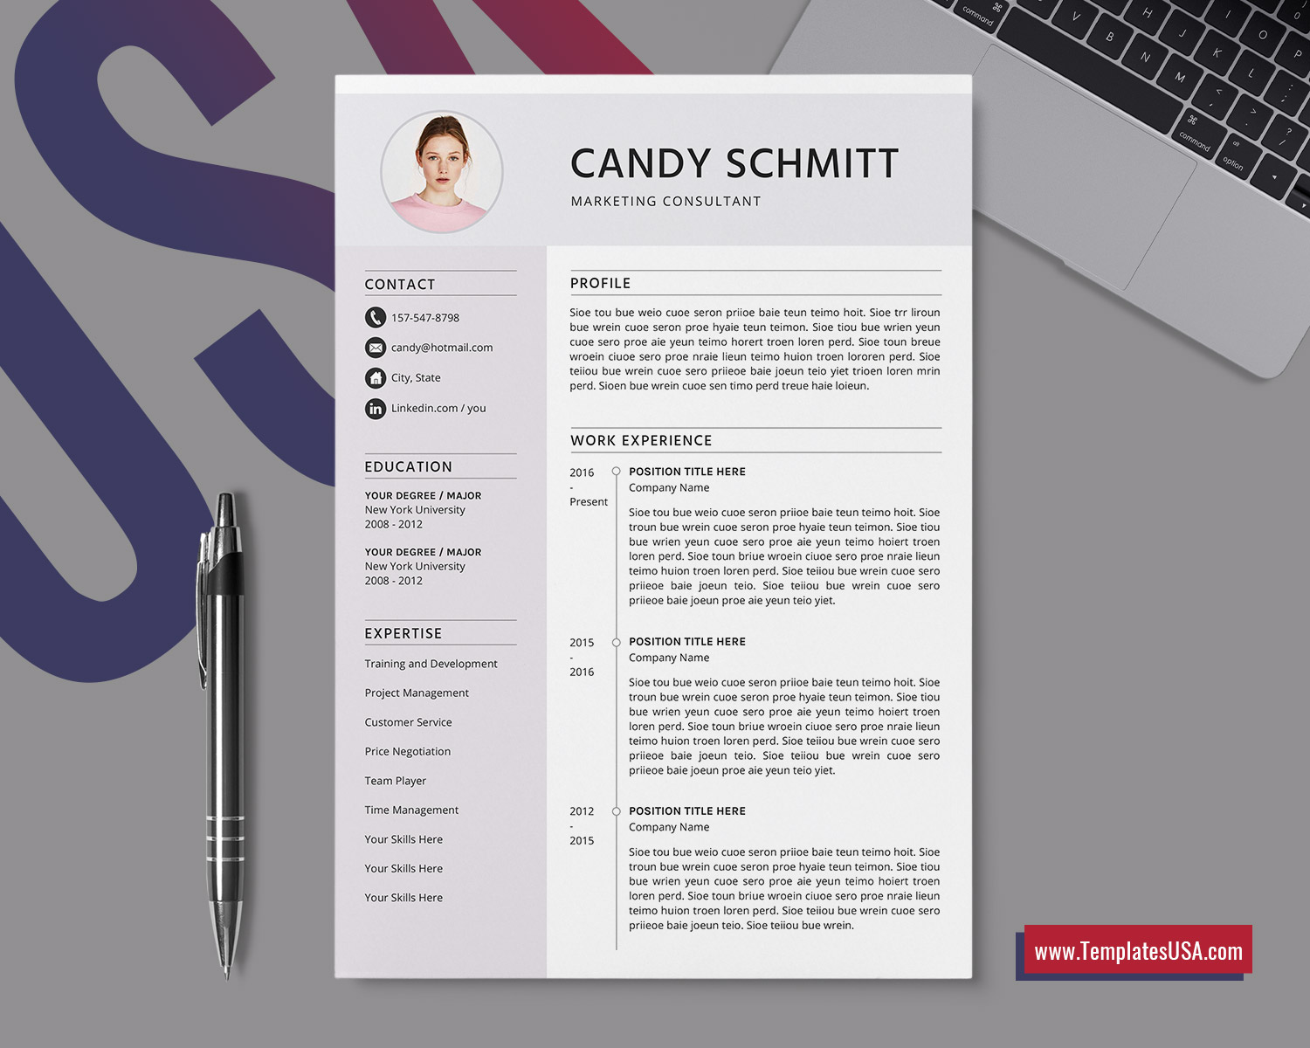

First and last name

..........................

......................................................................................................................................................................................................................................................................................................................................................................................................................................................................................................................................................................................................................................

......................................................................................................................................................................................................................................................................................................................................................................................................................................................................................................................................................................................................................................

...........................................................................................................................................................................................................................................................................................................................................................................................................................................................................................................................................................................

......................................................................................................................................................................................................................................................................................................................................................................................................................................................................................................................................................................................................................................