Instructor ;BAGHDADI.M

***Ahmed Zabana University of Relizane***

***Faculty of economics, business and management science***

***level : Master 2 Accounting***

***Syllabus***

Lesson 01 : Application Forms And letters

Lesson 02 : Job interviews

Lesson 03: The Company

Lesson 04 : The Features of Multinational Enterprises

Lesson 05 : Accounting

**Lesson 01: APPLICATION FORMS AND LETTERS**

**The objectives :**

*The learners be able to write their own application letter and the cv in English

*Provide new vocabularies in their domain .

**Overview :**

The first step towards getting a job is writing an application form. In different countries different conventions apply to the process of job application and interviews. A letter of application is in some countries expected to be handwritten, not word-processed. Many companies expect you to write all your personal information on a standard application form (see example below), but no two application forms are alike, so you may have difficulties filling them in.

An application letter is usually accompanied by a CV or resume.

**An application letter** is usually accompanied by a CV or resume.Not every company wants the form from above, but all of them expect you to write a good letter of application. In it you have to introduce yourself, be polite and persuasive, but not too pushy

**What is CV** : (short for the Latin phrase curriculum vitae, which means “course of life”) is a detailed document highlighting your professional and academic history. CVs typically include information like work experience, achievements and awards, scholarships or grants you’ve earned, coursework, research projects and publications of your work. You may be asked to submit a CV when applying for jobs.

If you need help determining how to write a CV, it can be helpful to consult a template. Here is additional background on the document along with an easy-to-follow CV example template to ensure you craft a powerful curriculum vitae that stands out to employers.

Letter writing –Applying for a Job :

|  |
| --- |
| Date _____________  Write the name of the person to whom you are writing for .  (their name not known write Sir, Madam ( Ms,Mrs )  Company Name / recipient Address  Mr:_____________  I am interested in the production Manager position as advertised in the “abc website,com” by your organization ,the requirements closely match my educational background and post experience .Hereby ,I have enclosed my resume to provide detailed information on my qualifications and skills for your review .Throughout my post professional career .I have undertaken various important responsibilities with utmost sincerity .I have conducted market analysis of services and products, prepared the analysis reports coordinated with the research data product team in order to ensure that the data collected are up- to – data and managed the product lead communication .I required the following skills after completing my four years college degree in business and finance from university .   * Sound knowledge of online media advertising . * Good interpersonal skills and communication skills * Ability to maintain good client relationship sound knowledge in service development with an urge to work both independently and well   I would look , forward to get an opportunity to meet with you to discuss my candidacy in more details . I thank you very much for your time and consideration .  Yours sincerely  Your name signature |

**Lesson 02:Job interviews**

**The objectives :**

*The learner be able to know how do the job interview do ?

*Provide new vocabularies to the learners in their domain

**Jobs Interview steps :**

If the company decides you may be an acceptable candidate, they will grant you an interview.

While you are preparing for the interview, you should:

* gather information about the company and study it carefully
* research the company by reading articles in business publications, professional journals, magazines or newspapers
* get information about the company’s strengths, about practice trends and about people who have been hired in the last few years
* if possible, attend presentations sponsored by this company or firm
* expand the self-assessment
* check the company’s Web site
* prepare several questions of your own.

There are different kinds of interviews: traditional one-to-one, panel (where a candidate is interviewed by a group of people) and deep-end (where applicants have to demonstrate they can cope in different and actual business situations) interviews. The atmosphere of an interview may be formal or informal and the interviewer may take a friendly, neutral or even hostile approach. Different interviewers use different techniques and the only rules you should be aware of may be: ‘Expect the unexpected’ and ‘Be yourself’!

Do not make up things or exaggerate at the interviews as the truth will come out very quickly and you will probably not be able to keep a job or a position if you have lied at the interview!

Although no two interviews are alike, the following guidelines may help you:

* dress appropriately, rather conservatively
* arrive on time
* offer your interviewer a smile and a firm handshake
* maintain eye contact with your interviewer
* pay attention to your body language
* express yourself in complete thoughts, use proper grammar, answer a question as clearly and logically as you can
* demonstrate in your answers your understanding of the employer’s goals
* if you don’t understand the question, ask the interviewer to clarify it for you
* do not ask about salary, but feel free to ask about training and career paths

thank the interviewer, offer another smile and a firm handshake, ask for a card

Simulate a job interview; ask very thorough questions about the candidate’s previous work experience.

**Thank you and acceptance letters**

After the interview you can send your interviewer a thank you note or a thank you letter, but do it in 48 hours. You can use a personal tone as you already know the person. You should stress again that you are interested in the position.

If the interviewer has requested any materials, such as additional references or work samples send them together with the thank you note.

**REMEMBER:** when you write different kind of letters that you are sending by post, you also have to be very careful how to lay addresses on the envelope

**Starting A New Job:**

When you are to start a new job, there are some very important rules to follow; some are the same as the ones mentioned when attending an interview:

* arrive on time or five minutes early
* wear your best office clothes, but be careful not to exaggerate
* shave
* go to the hairdresser’s a few days before
* try to get enough rest the night before
* smile at everybody you meet
* try to remember the names of people you are introduced to
* make a note of everything anyone tells you
* answer politely to all the questions
* try to look and act efficiently
* if you are a smoker, be careful because most countries have very strict rules about smoking
* enquire about any additional specifics of the company
* don’t be too pushy: remember that other people were there before you and have much more experience.

**The common questions and answers that we find them in the interview :**

**Q1:** Why should we hire you ?

**A1 :** If you hire me , it will be a great platform to showcase my skills ,whatever goals I set .I ensure to complete them within stipulated time .

**Q2 :** Reasons behind leaving your last job ?

**A2:** In order to enhance my skills set .I am looking for better opportunities .

**Q3:**Why have you been unemployed for such a long time ?

**A3:** I enrolled myself for some advanced personality developed course with some freelance work .

**Q4:**: Tell me your ability to work under pressure ?

**A4:** I keep myself cam and focus on multitasking while being patient .

**Q5:** What are your expectations from job ?

**A5:** Professionally advancement and good future .

**Q6:** Describe your management style ?

**A6 :** I will be constantly keeping tab of assigned work with my subordinates and seniors , finishing the assigned job before deadlines

**Q7:** Are you a team player ?

**A7:**Yes , the team which I was a past , have successful completed the project within deadlines .

**Q8:** what irritates you about co-workers ?

**A8:** I believe in team work .Even if I find anything irritating .I try to avoid it unless it personally affect me .

**Q9 :** How long would you expect to work for us if hired ?

**A9:** As long as I feel challenged professionally .

**Q10:** How do you see yourself after 5 years from now ?

**A10 :** I see myself in senior position managing important portfolio of this company .

**Q11:** Do you consider yourself successful ?

**A11 :** Yes, a part from appraisals .I think I have earned a bunch of good colleagues in my life .

**Q12:** What is your weakness ?

**A12 :** I concentrate on one thing at a time .

**Q13 :** What is your strength ?

**A13 :** I am a quick learned and great team player .

**Q14 :** What position do you prefer on a team working on a project ?

**A14 :** It doesn’t matter till learn something new in every project

**Q15 :** D you have any question ?

**A15 :** When can I join .

**lesson 03** : The company

Definition ;

Company means a business its self , company is a legal entity that people form ,it allows them ,usually as shareholders ,to buy and sell goods or services ,the most companies want to make a profit however some companies are non- profit organizations

Company means a business

Office means employee’s specific work area .

Company’s structure

Headquarters : The main ( the most important office a company has

Department : All of the employees of a specific type in a company .

Industry : All of the companies of a specific type .

Branch: a division that operates in a certain area .

|  |
| --- |
| An example of a company organization chart  Source: Mackenzie, 1997, page 20 |

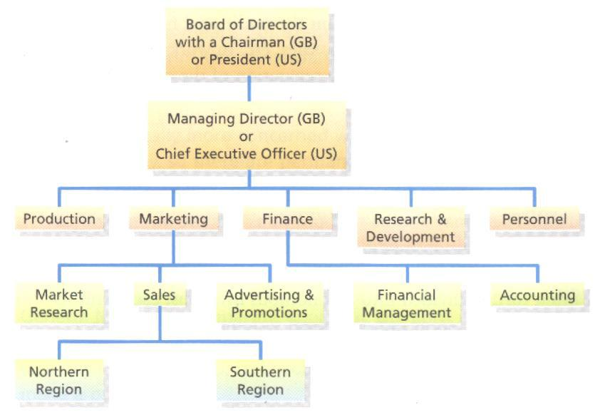

Reminder :

Company : when we talking about an entire Business

Office : For the physical area where the employees work

Headquarters : for a company’s main important office

Department ; For a the employees of a specific types in a company

Industry : For the companies of a specific type

Branch : For a specific section /area of a company

**lesson 04:** Features of Multinational Enterprises .

Multinational enterprises (MNE):a business entity which conducts business operations in a various countries with its subsidiaries and affiliates .It posses considerable and wide human resources finance ,expertise and technology as we as enjoy substantial competitive advantage .

**Types of multinational enterprises :**

Multinational decentralized corporations :every branch office has decentralized management structure with no central chain of command for decision-making .

Global centralized corporation :centralized firm manages and controls the international units from the headquarters in a home country .

International company : in this , the global branches adhere to the parent company’s technology improvisations occurs in the headquarters .

Transnational enterprises : it is the blend of all the above three forms of MNC ,the parent company guides but not controls the functioning of its global branches .

**The features of MNEs:**

*large scale operations the basic feature of MNEs is that their area of operations is vast

*large number of branches they operate a global level and have branches in different countries .

*Huge turnover : the amount of MNE is high which they able to pay a good amount of salary to their employees

*High products quality : the product that produced by MNEs are of high quality

*Large scale advertising : another essential feature that they invest huge amount of money in their advertisement and publicity activities .

*Control from the home country

*Advanced technology : they focus on best level technology .

**The advantages of MNEs :**

**1/ Fore the country :**

*Financial gains

*Increase in business

*Job creation

*access to more goods and services

*assistance in economic development

**2/Fore the company :**

*Access to new markets

*Cost efficiency

*More creativity and innovation

*Global brand recognition

*Diversified work

|  |
| --- |
| Task : write a short essay where you talk about the disadvantages of multinational enterprises . your work should be in less two pages |

**Lesson 05**: Accounting .

**1/ Accounting definition :**

Accounting is the process of recording financial transactions pertaining to a business. The accounting process includes summarizing, analyzing, and reporting these transactions to oversight agencies, regulators, and tax collection entities. The financial statements used in accounting are a concise summary of financial transactions over an accounting period, summarizing a company's operations, financial position, and [cash flows](https://www.investopedia.com/terms/c/cashflow.asp).

**Types of Accounting**

[**Financial accounting**](https://www.investopedia.com/terms/f/financialaccounting.asp) **:**

refers to the processes used to generate interim and annual financial statements. The results of all financial transactions that occur during an accounting period are summarized into the balance sheet, income statement, and cash flow statement. The financial statements of most companies are audited annually by an external CPA firm. For some, such as publicly traded companies, audits are a legal requirement.6 However, lenders also typically require the results of an external audit annually as part of their debt covenants. Therefore, most companies will have annual audits for one reason or another.

[**Managerial accounting**](https://www.investopedia.com/terms/m/managerialaccounting.asp)

uses much of the same data as financial accounting, [but it organizes and utilizes information in different ways](https://www.investopedia.com/ask/answers/041015/how-does-financial-accounting-differ-managerial-accounting.asp). Namely, in managerial accounting, an accountant generates monthly or quarterly reports that a business's management team can use to make decisions about how the business operates. Managerial accounting also encompasses many other facets of accounting, including budgeting, forecasting, and various financial analysis tools. Essentially, any information that may be useful to management falls underneath this umbrella.

**Cost Accounting**

Just as managerial accounting helps businesses make decisions about management, cost accounting helps businesses make decisions about costing. Essentially, cost accounting considers all of the costs related to producing a product. Analysts, managers, business owners, and accountants use this information to determine what their [products should cost](https://www.investopedia.com/ask/answers/060915/what-difference-between-transfer-price-and-standard-cost.asp). In cost accounting, money is cast as an economic factor in production, whereas in financial accounting, money is considered to be a measure of a company's economic performance.

## Forensic accounting

Forensic accounting combines accounting, auditing, and investigative skills to examine the finances of an individual or business. Forensic accountants compile financial evidence and can communicate their findings using reports and presentations in legal proceedings. This type of accounting is often used in fraud and embezzlement cases, as it provides a detailed explanation of the nature and extent of a financial crime.

## Fiduciary accounting

Fiduciary accounting is the recording of transactions associated with a trust or estate. It is dealt with on a cash basis. Cash is recorded when it is received and disbursements are recorded when paid. This information is then provided to beneficiaries and often the courts.

## Auditing accounting

Auditing accounting is an objective examination and evaluation of a company's financial statements done internally or by a government entity, such as the Internal Revenue Service .

***Good Luck***